
Studymate.ai
Project Proposal

Group Members
Fawaz Ahmed (Group Leader) 21K-4717
Shahzaib Mirza 21K-3819
Muhammad Daniyal 21K-4723

Project Supervisor

Name: Ms. Saeeda Kanwal

National University Of Computer and Emerging Sciences
Karachi, Pakistan

Abstract
As the demand for personalized and efficient educational tools increases, the integration of AI in learning systems becomes vital to meet the needs of students and educators. StudyMate.ai is a final year project designed to streamline the educational experience through advanced AI-powered features. This system provides automated content creation, along with video summarization, tailored to individual student needs. By leveraging Natural Language Processing (NLP) and machine learning, StudyMate.ai offers personalized study recommendations, optimizing learning outcomes. Additionally, the platform includes a parental dashboard for real-time progress tracking, promoting collaborative learning.

Introduction
StudyMate.ai is a cutting-edge, AI-powered student management system developed to significantly enhance the educational experience for teachers, students, and parents alike. By harnessing advanced AI technologies, it offers a suite of core functionalities designed to streamline learning processes. One of its standout features is the ability to automatically generate comprehensive quizzes and practice exams from various input documents, such as textbooks and PDFs. This automation saves educators valuable time by eliminating the need for manual quiz creation, allowing them to focus more on engaging with students. For students, it provides customized study materials tailored to their individual progress and learning needs.

Additionally, StudyMate.ai goes beyond static text by incorporating AI-driven video summarization capabilities. It distills complex educational videos into key points and essential concepts, making it easier for students to grasp and revise content quickly. By integrating features such as personalized quiz generation, real-time feedback, and progress tracking, it aims to create a more interactive, efficient, and adaptive learning environment. The platform also fosters better parental involvement by providing tools to monitor academic progress, ensuring a comprehensive, collaborative approach to education.

Background
Education in today’s fast-paced world demands innovative solutions that cater to the needs of diverse learners while easing the workload for educators. As students face increasing academic pressure, the integration of AI in education has emerged as powerful tool to meet these demands. Many online AI tools provide such features though they are paid and not open source. This is where StudyMate.ai comes in designed to address these challenges.

Purpose
The primary purpose of this final year project was to design, develop, and evaluate an AI-powered student management system, StudyMate.ai, tailored to the needs of students that lack advance education and provide them with tools to streamline their education. The online applications available right now provide the features though they are limited, paid and not customizable hence our project will be a better option.

Major Points of Research
- AI-Driven Content Generation:
StudyMate.ai leverages advanced Natural Language Processing (NLP) algorithms to automatically generate quizzes, notes, and study materials, tailored to individual learning progress.
- Personalized Learning:
A key focus is on personalization, AI algorithms to adapt study recommendations and content based on each student’s performance and learning needs.
- Parental Involvement:
StudyMate.ai enhances parental engagement by providing real-time academic progress tracking, ensuring better communication between parents, teachers.
- Collaborative Learning Environment:
The platform promotes collaboration and interaction between students, educators, and parents to create a more efficient and supportive learning ecosystem.

Objectives
- Automate Study Material Generation:
Develop an AI system to automatically generate quizzes, exams, and customized study materials from input documents like PDFs and textbooks. This automation saves educators time and ensures that students receive relevant and structured practice materials tailored to the curriculum.

- Enhance Video Learning:
Implement AI-powered video summarization to extract key concepts from educational videos, helping students revise content more quickly. This feature condenses lengthy videos into concise summaries, making it easier for students to focus on essential points during revision.

- Personalize Learning Experiences:
Use AI to tailor study material recommendations based on individual student progress and performance. By analyzing students' learning patterns, the system provides personalized resources, helping them focus on areas that need improvement.

- Improve Teacher Efficiency:
Automate quiz creation and study material preparation, reducing the time teachers spend on administrative tasks. This allows teachers to dedicate more time to teaching, student engagement, and improving the overall classroom experience.

- Simplify Parent Involvement:
Provide parents with an easy-to-use interface to monitor their child’s academic progress and quiz results. This feature keeps parents informed about their child’s performance, enabling better support and communication between parents, teachers, and students.

Key Features
- Free Access:
The platform will be entirely free, removing financial barriers for educators and students.

- PDF Uploads:
Users can upload larger PDFs, surpassing the page and character limits found in other systems.

- Targeted Quiz Generation:
Quizzes can be generated based on specific sections, page ranges, or topics from documents, rather than from the entire document.

- Answer Validation and Explanations:
The platform will validate answers and provide explanations for incorrect responses to improve student comprehension.

- Customizable Timed Quizzes:
Users will be able to set a timer for quizzes, helping students practice time management skills.

- User Dashboards:
Teachers: Add student’s numbers and attendance, and view student progress.
Students: Upload PDFs, generate quizzes, access study materials and personalized progress reports.
Parents: Monitor student progress and engagement.

Literature Review
The integration of AI in education has brought about a transformative shift, revolutionizing how students learn and how educators teach by automating traditionally time-consuming tasks such as content and quiz generation. AI technologies like Natural Language Processing (NLP) and machine learning now enable the automatic generation of quizzes and exams from input documents, including PDFs, textbooks, and other educational resources. This not only saves teachers countless hours but also ensures that students receive consistent, high-quality assessments tailored to their specific needs and curriculum.

In addition to quiz generation, AI-based video summarization represents another key advancement in the field of educational technology. By employing sophisticated techniques such as extractive and abstractive summarization, AI condenses lengthy educational videos into concise summaries, extracting key points and essential concepts. This enables students to retain information more effectively while also facilitating quick revisions, especially during exam preparation or when revisiting complex subjects.

Personalized learning systems have become a central component of modern education, as AI models can now adapt study materials to individual student performance. These systems analyze student progress using machine learning algorithms and provide targeted recommendations based on each student's unique strengths and areas for improvement. This level of personalization enhances learning outcomes and boosts overall efficiency, offering students a more tailored and engaging educational experience.

Moreover, AI-powered platforms that involve parents in the learning process further improve educational outcomes. By allowing parents to monitor their child's academic progress in real time, these platforms foster better communication between parents, teachers, and students. This collaboration contributes to improved student performance, as parents become more engaged in supporting their child's educational journey. The seamless integration of AI across these areas marks a significant step forward in making education more adaptive, efficient, and personalized.

Methodology
- Model Training and Fine-tuning:
Pre-trained NLP models will be fine-tuned on domain-specific educational data. This included tuning models on the basis of question-answering tasks, text summarization, and video speech analysis.

- System Integration:
Developed a RESTful API layer using Flask for handling communication between the frontend and backend. The backend manages requests related to quiz generation, video summarization, and recommendation engines. Extensive use of microservices architecture ensures that different modules can scale independently as system usage grows.
- Testing and Validation:
Multiple rounds of testing will be conducted with both students and teachers. The quiz generation algorithm will be validated for accuracy and relevance, while video summaries will be assessed for completeness. The personalization engine will be rigorously tested for its ability to recommend relevant content based on actual user performance.
System Diagram
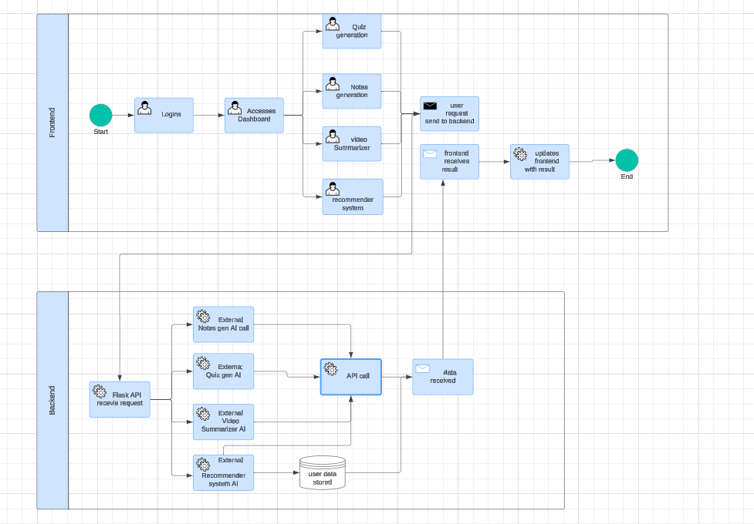.

Timeline

Conclusion
By addressing the limitations in existing products, StudyMateAI revolutionizes the educational landscape with a free, accessible, and highly functional platform. Its unique features expanded upload capacity, targeted quiz generation, answer validation, and time management support ensure a more personalized, efficient, and effective learning experience.

